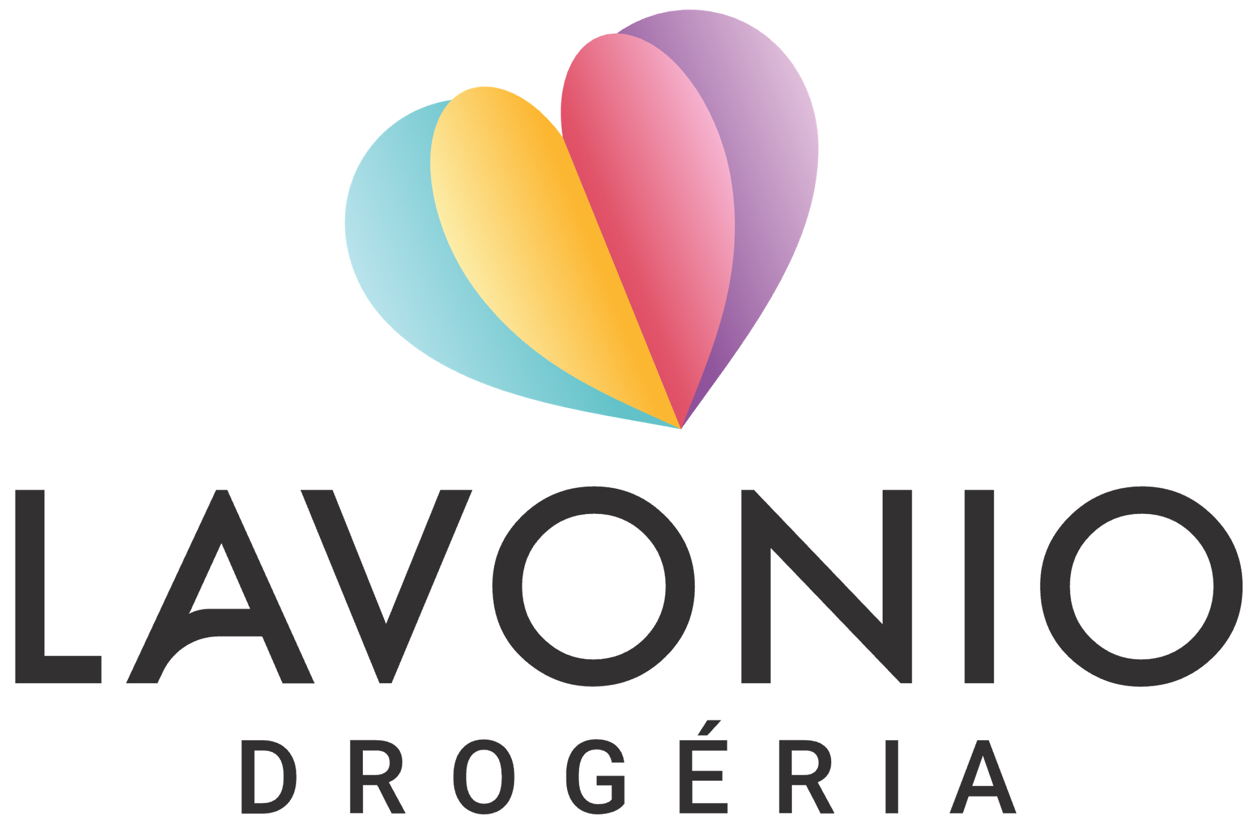FORMULÁR  
**na vrátenie tovaru alebo podanie sťažnosti**

Vyplňte tento formulár a zašlite ho spolu s tovarom na našu adresu Janka Palu 169/11A, 914 41 Nemšová, Slovenská republika.

ÚDAJE O SPOTREBITEĽOCH  
Meno a priezvisko....................................................................................................... Adresa........................................................................................................................ Telefon........................................... Email...................................................................   
Objednávacie číslo........................................... Dátum prijatia..................................

ODSTÚPENIE OD KÚPNEJ ZMLUVY

Týmto oznamujem, že odstupujem od zmluvy o kúpe tohto tovaru: ................................................................................................................................. ................................................................................................................................. ................................................................................................................................. .................................................................................................................................

Číslo účtu pre refundáciu.....................................................................

Dátum......................... Podpis zákazníka.........................

Priložte kópiu faktúry.

AK JE DARČEK SÚČASŤOU OBJEDNÁVKY A VRACIATE CELÚ OBJEDNÁVKU, POŠLITE AJ HODNOTNÝ DARČEK. V PRÍPADE ČIASTOČNÉHO VRÁTENIA DARČEK PATRÍ VÁM.